Differential Equation Exercises

These exercises cover a range of techniques and methods used in solving linear differential equations and will provide good practice for mastering the topic.

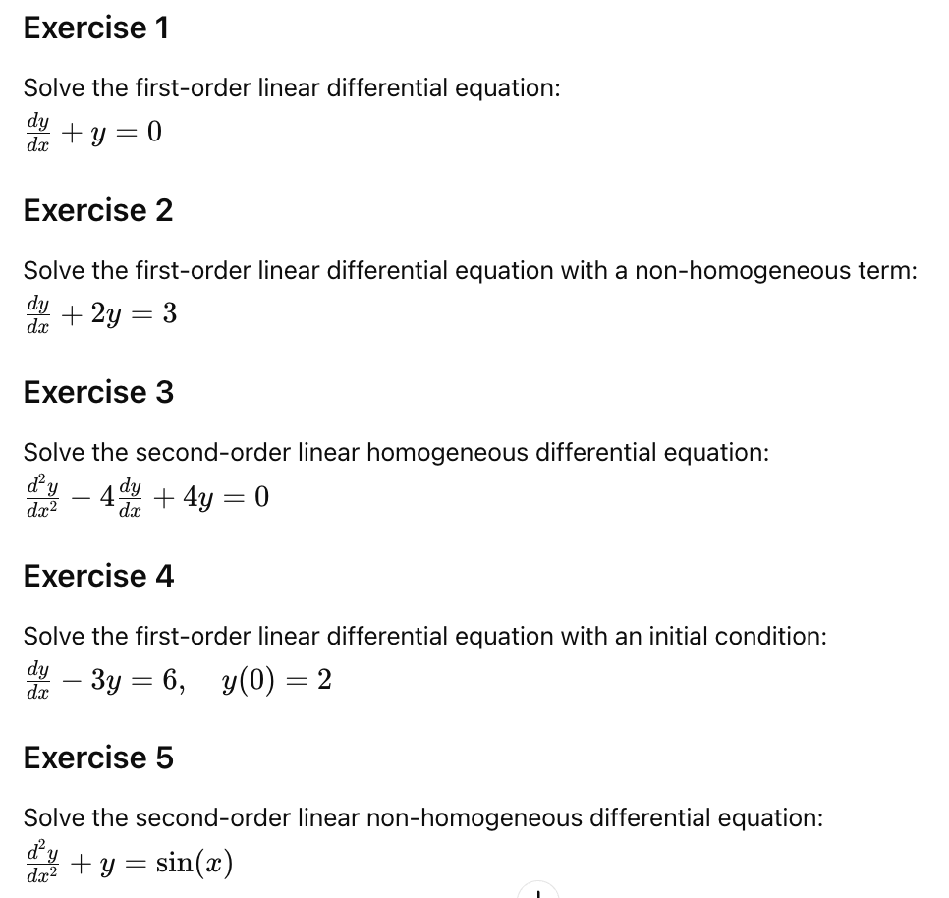

Hints for Solutions

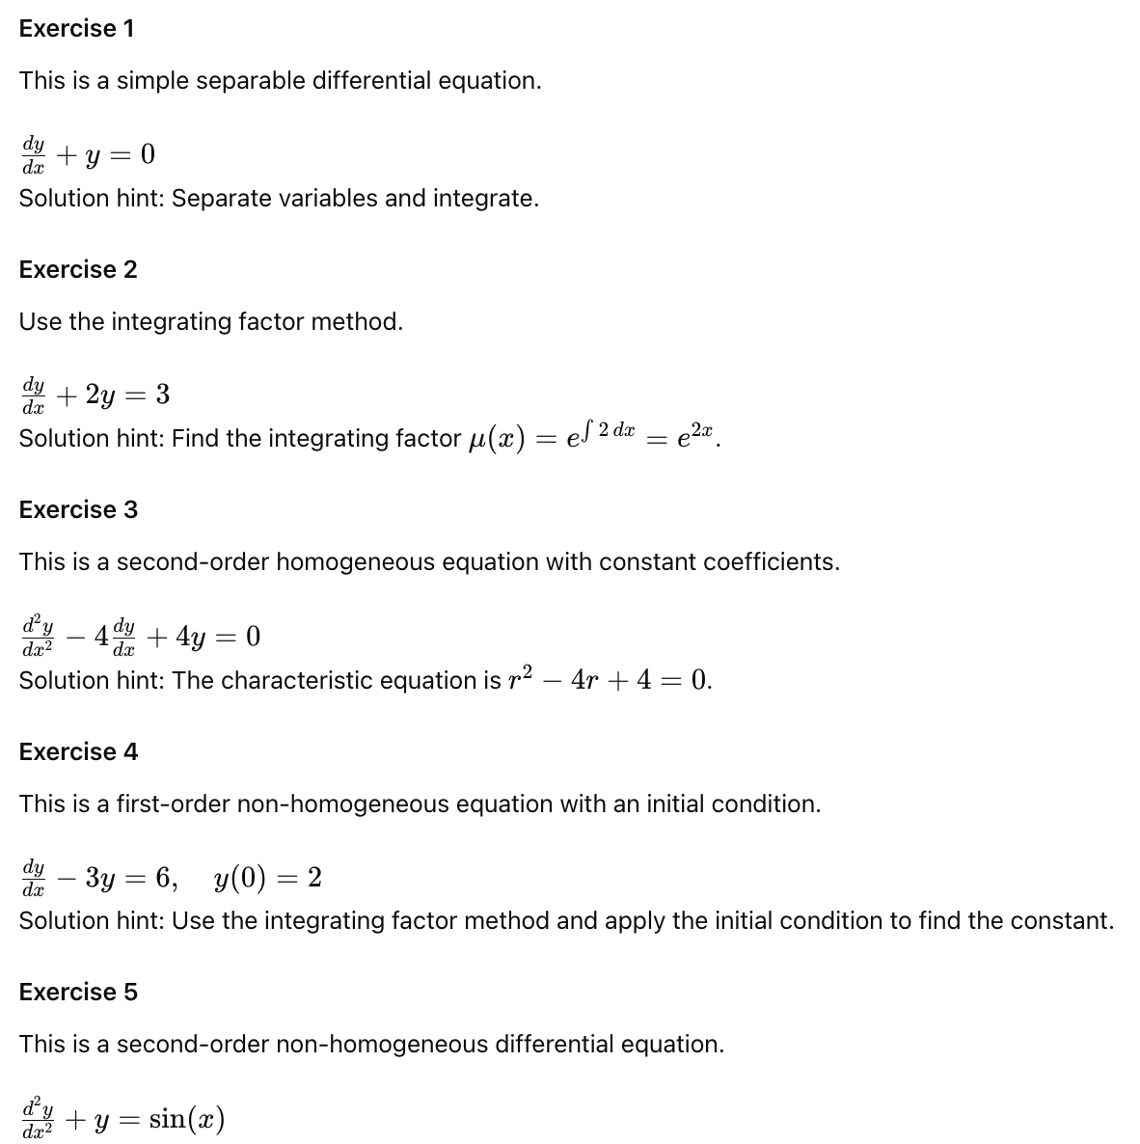
Solution hint: Solve the corresponding homogeneous equation first, then find a particular solution to the non-homogeneous equation using the method of undetermined coefficients.

